What can we do on Cloud

Service: This is what is offered Resource: This is what we have created.

# Picking Services

Scenario: My organization is running applications on Redhat Linux server which is present on-premises. How to achieve the same in

Azure:

AWS

Virtual Machines

EC2

Scenario: We need to run Microsoft SQL Server (Database)

Azure:

AWS

Azure SQL

RDS

Typical Enterprise Needs

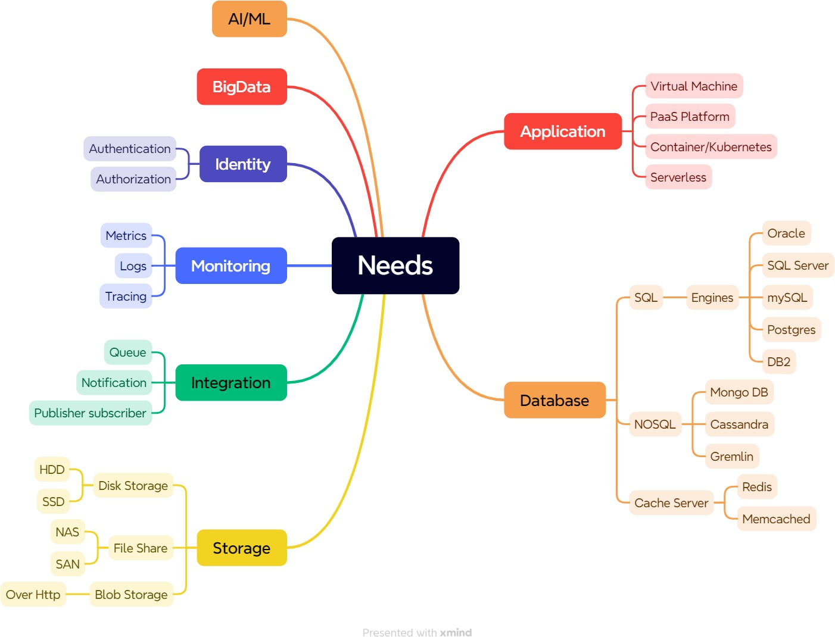

Job roles

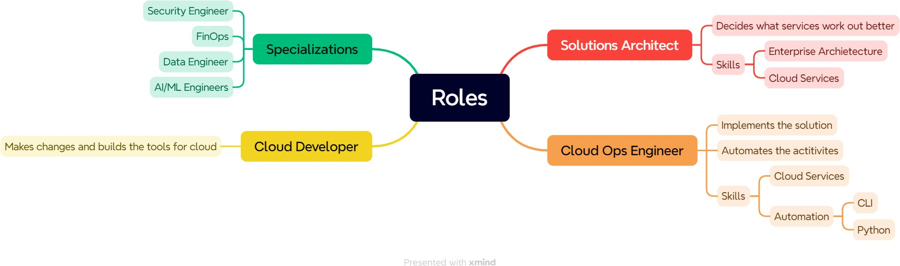

# Identity and access management

Cloud Account

How to create users & give them right permissions

How Enterprise cloud accounts will be different from our free tier accounts Creating, auditing and managing the users, resources for cloud account Governance:

Identity as a Service for applications

# scenario: Question 1

My application uses

Oracle DB Server

Application developed on java running on ubuntu linux Load Balancer

If I want to use the below cloud what will be the services AWS

Azure

Oracle => RDS

Linux Instance => EC2 Elastic Bean stalk ECS

EKS

Load Balancers ALB NLB

Azure => VM Java App

Azure VM

Azure App service AKS

ACI

Load Balancers LB

What are services available for Disaster recovery in AWS/Azure?

**Disaster Recovery Services in AWS and Azure**

**AWS (Amazon Web Services)**

1. **AWS Elastic Disaster Recovery (AWS DRS)**
   * Enables fast, reliable recovery of on-premises and cloud-based applications.
   * Provides automated failover and failback.
2. **AWS Backup**
   * Centralized service to manage and automate backups across AWS services like EC2, RDS, and DynamoDB.
3. **AWS CloudEndure Disaster Recovery**
   * Continuous block-level replication for quick disaster recovery.
   * Reduces downtime and data loss by keeping a standby environment.
4. **Amazon S3 Cross-Region Replication (CRR)**
   * Automatically replicates objects across AWS regions for disaster recovery.
5. **AWS Storage Gateway**
   * Connects on-premises software appliances with AWS cloud storage to facilitate recovery processes.

**Azure**

1. **Azure Site Recovery (ASR)**
   * Automates the replication of on-premises and Azure virtual machines.
   * Ensures business continuity through failover and failback.
2. **Azure Backup**
   * Provides backup and restore capabilities for Azure VMs, SQL databases, and on-premises data.
3. **Geo-Redundant Storage (GRS)**
   * Ensures that data is replicated to a secondary region to protect against regional disasters.
4. **Azure Blob Storage with RA-GRS**
   * Offers read-access geo-redundant storage, enabling data availability during regional outages.
5. **Azure Disaster Recovery as a Service (DRaaS)**
   * Provides managed disaster recovery solutions for critical workloads.